Thursday August 24th 11am-2pm
Teacher Parking Lot
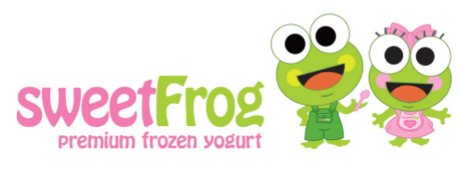
Possible flavors include:
Chocolate, NSA Vanilla, Mango Sorbet, Cake Batter

Toppings included in price:
Cherries, Strawberry Poppers, Oreos, M&Ms, Reeses, Granola, Sour Gummy Worms,
Gummy Bears, and Fresh Fruit*

8 oz cup: $5
12 oz cup: $7
*upon availability

